Thrifters - Social Networking Website
Name: Fabasshir Islam
Student ID: M01043814
Subject Code: CST2120
Date: December 12, 2025
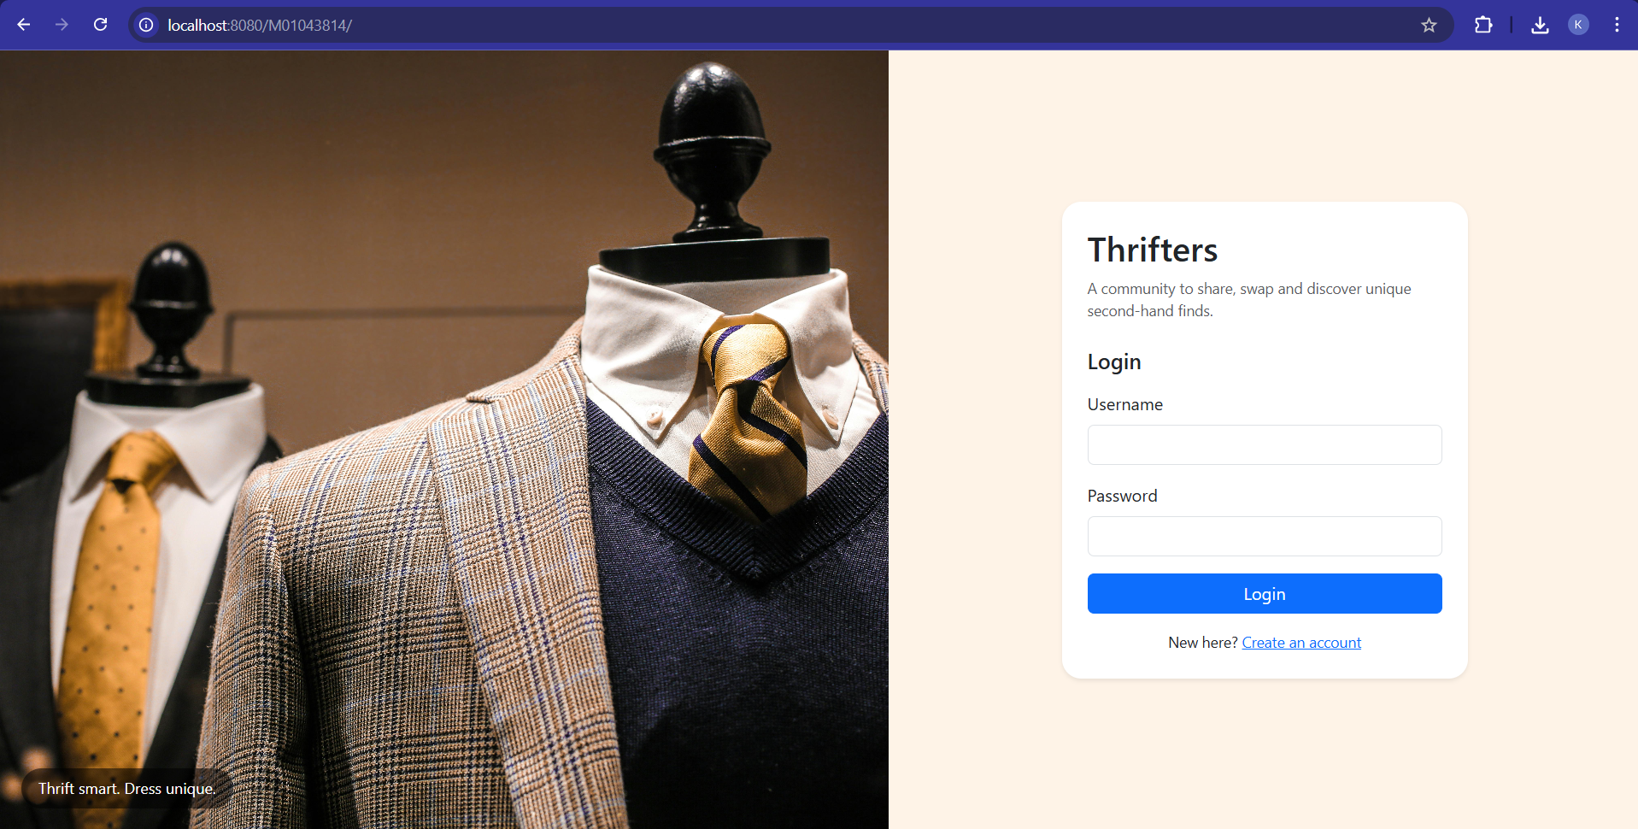

Introduction
Thrifters is a social networking web application for buying and selling second-hand items. Users can register and log in, post items with images, follow sellers, browse a personal feed, favourite items, purchase items, and view weather-based shopping hints. The site is implemented as a single HTML page (vanilla JS + CSS + Bootstrap) that communicates with a Node.js + Express web service via AJAX (fetch) returning JSON. All data is stored in MongoDB using the official mongodb Node driver. Images are stored on the server’s filesystem via AJAX uploads. All service paths begin with my student ID.

1. Coursework Alignment Summary
This project implements the key requirements from the Coursework 2 brief:
- Single-page front end: exactly one HTML page (index.html). JavaScript updates sections dynamically. Data exchanged post-load is JSON only. Images are the exception (AJAX upload).
- Server technology: web service on localhost using Express on Node.js; all paths start with my student ID and the ID is hardcoded, not parameterized.
- Front-end libraries: No frameworks like React/Vue are used. Only Bootstrap was used.
- AJAX/JSON: front end communicates with the server using fetch(); all responses are JSON.
- MongoDB storage: data stored in MongoDB, accessed via the official mongodb Node module (no Mongoose/Prisma).
- Required paths implemented:
  - POST /{STUDENTID}/users (register), GET /{STUDENTID}/users?q=... (search users)
  - GET|POST|DELETE /{STUDENTID}/login (status, login, logout) with session management
  - POST /{STUDENTID}/contents (create post), GET /{STUDENTID}/contents?q=... (search posts/items)
  - POST|DELETE /{STUDENTID}/follow (follow/unfollow)
  - GET /{STUDENTID}/feed (feed from followed users only)
- Uploads: images uploaded via AJAX and stored on the server’s filesystem under the student-ID path.
- Third-party data: weather is fetched server-side (monthly summary/suggestion endpoint /{STUDENTID}/weather?...) and returned to the front end through our web service (not fetched directly by the browser), as required.
- Deliverables: I will include (a) Postman screenshots for each method/path, (b) screenshots of all front-end functionality, (c) a JSON/BSON database dump, and (d) a ≤5-minute video demonstration per submission rules.

2. Website Overview
Landing page: left side auto-carousel (branding images), right side auth card (login & register toggle).
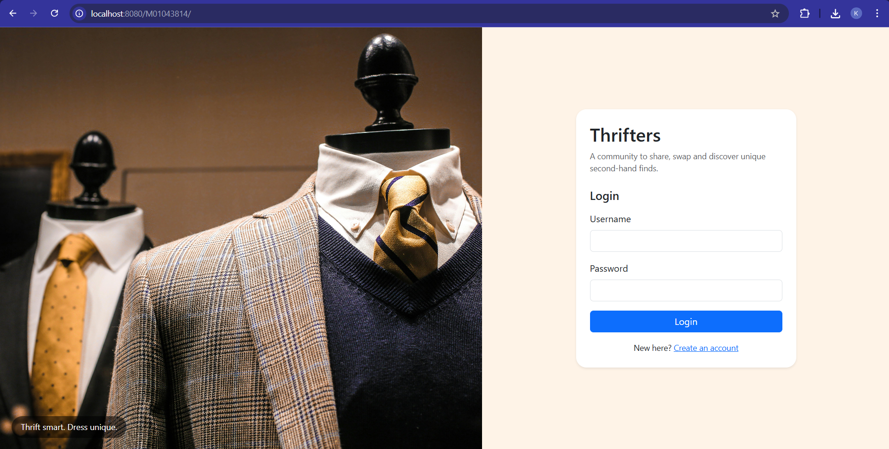
App layout after login:
- Header: brand, search bar, “My Profile” and Logout.
- Sub-nav: Feed, Favourites, Post Item (opens modal), Purchased Items.
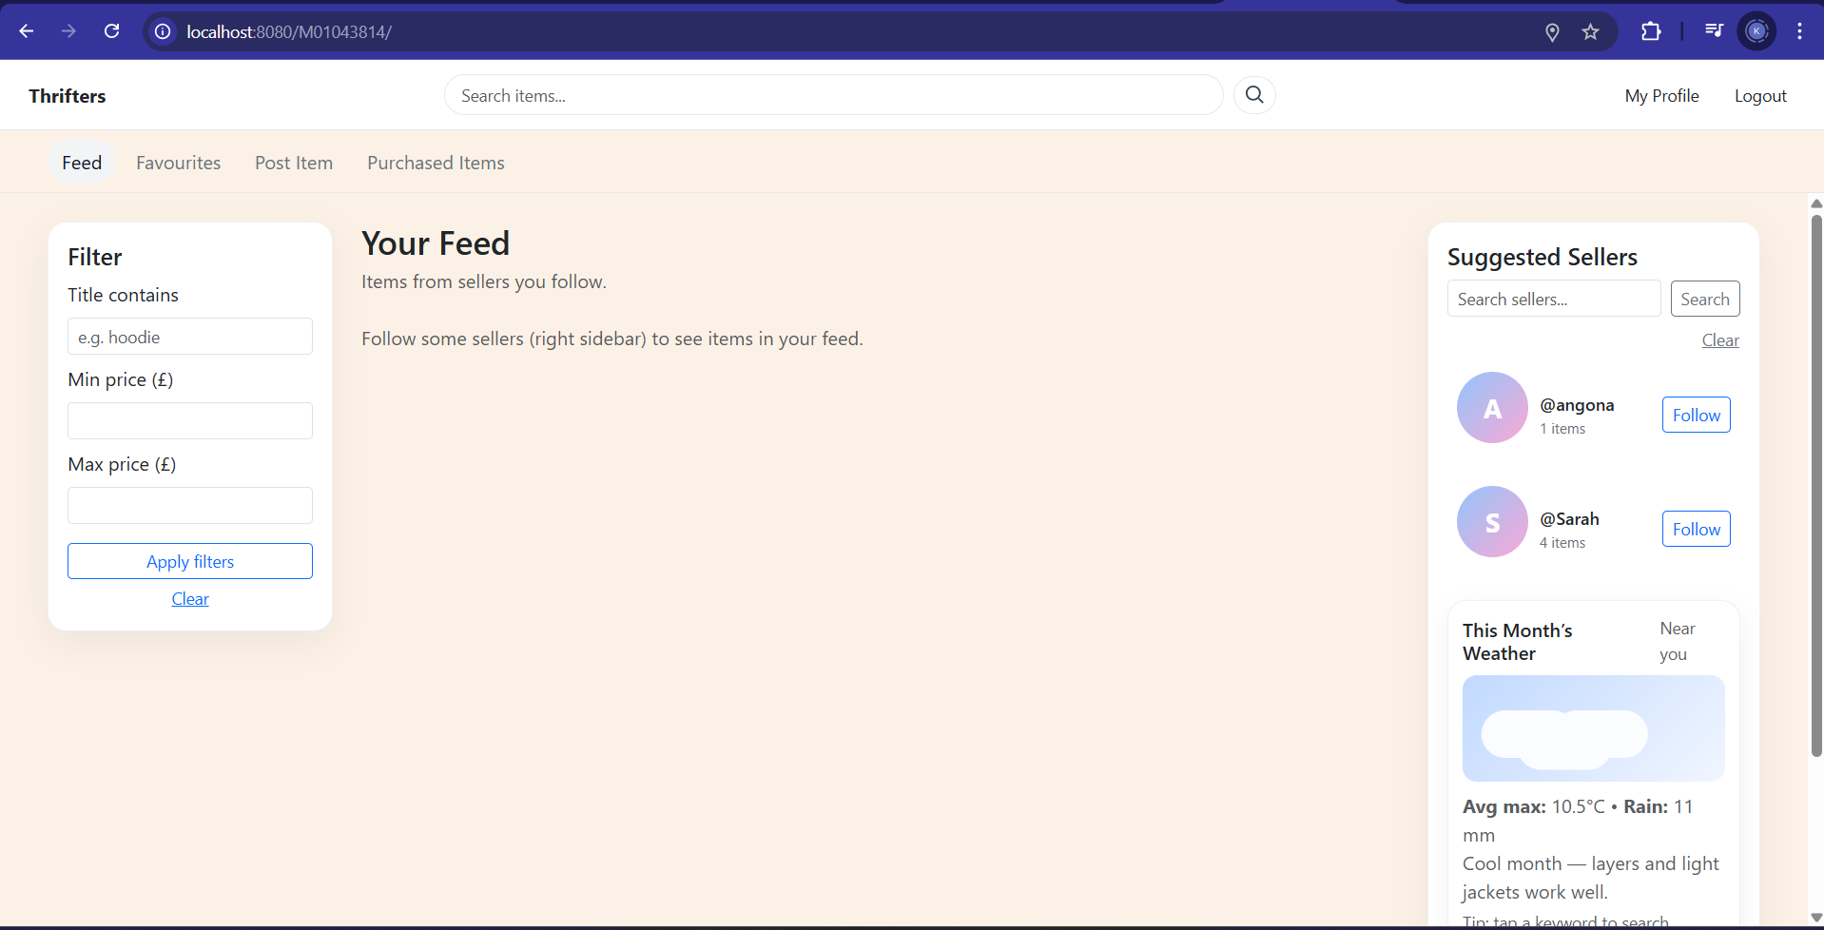
- Feed page (center column): 3-column card grid of items posted by followed sellers. If the user follows no one, the feed is empty with a prompt to follow sellers.
- Left sidebar: client-side filters (title contains, min/max price).
- Right sidebar:
  - Suggested Sellers list (with a seller search bar and Follow buttons).
  - Weather panel (auto-detects location; animated scene + monthly summary text + keyword chips that trigger searches.
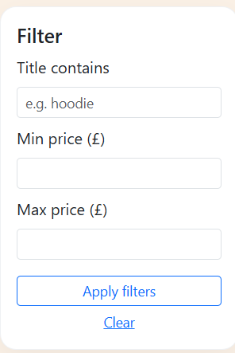
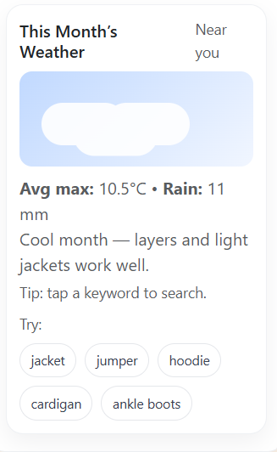
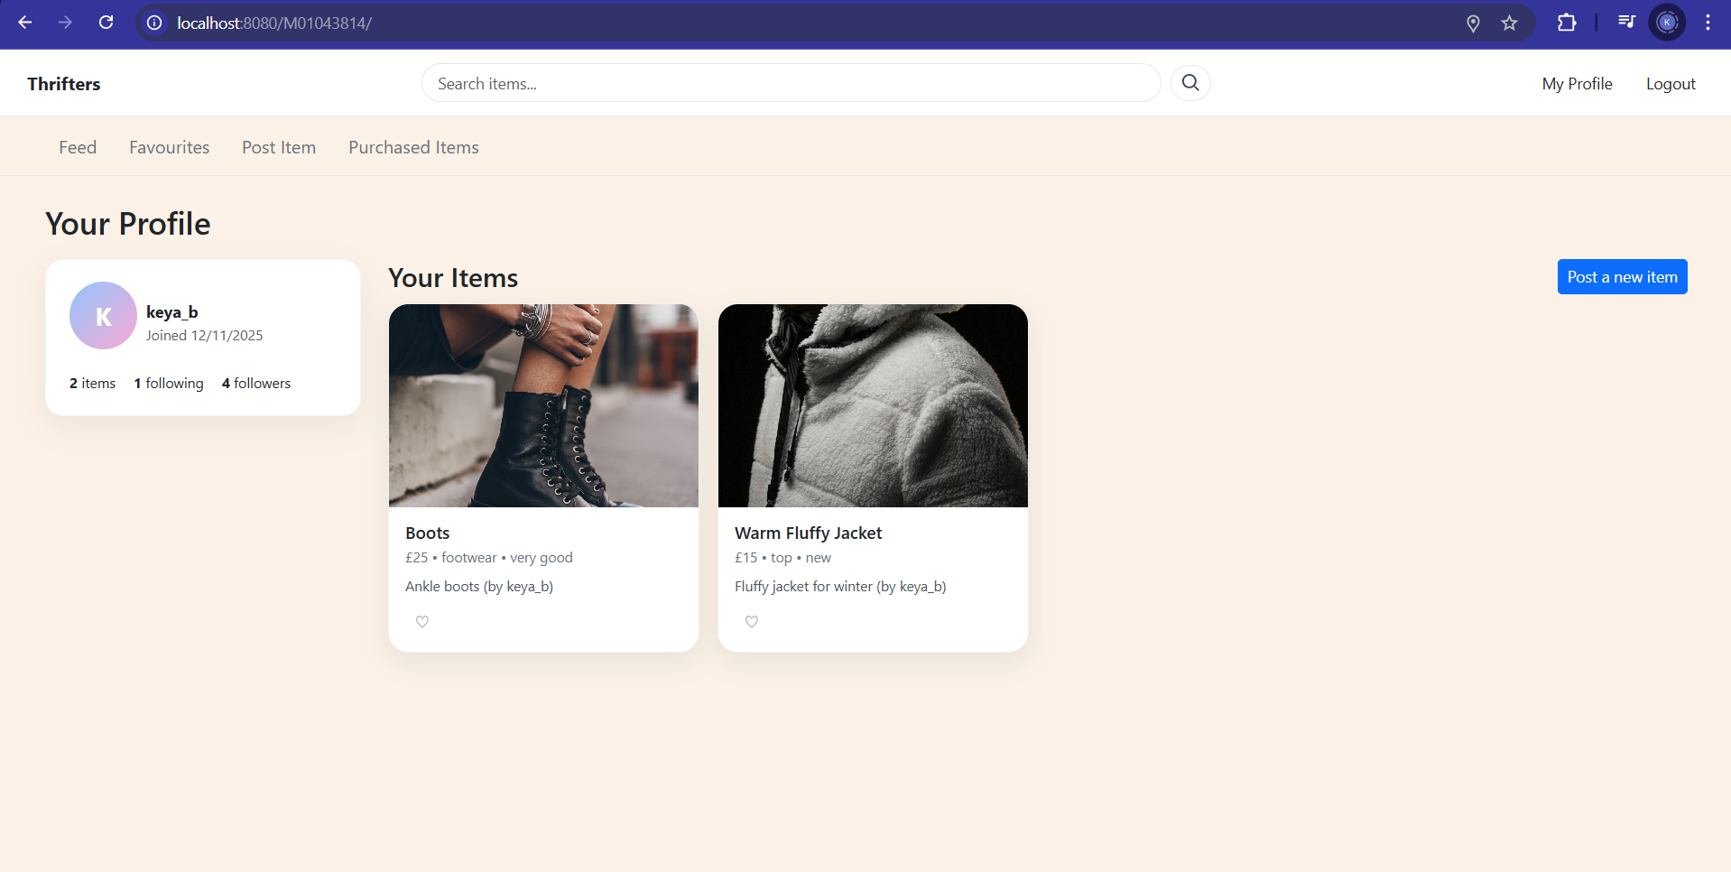
- Profile page: basic user info & stats; grid of my items (including SOLD badges). “Post item” button opens the modal.

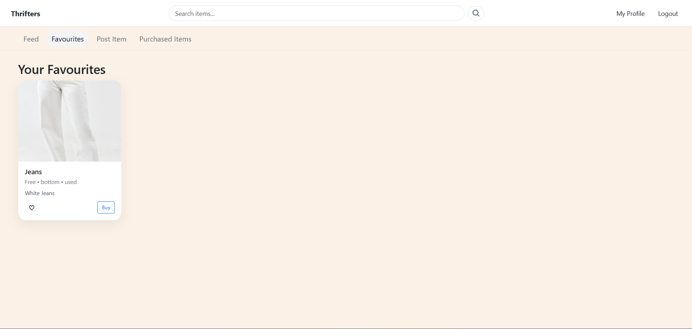
- Favourites page: grid of items marked with a heart.

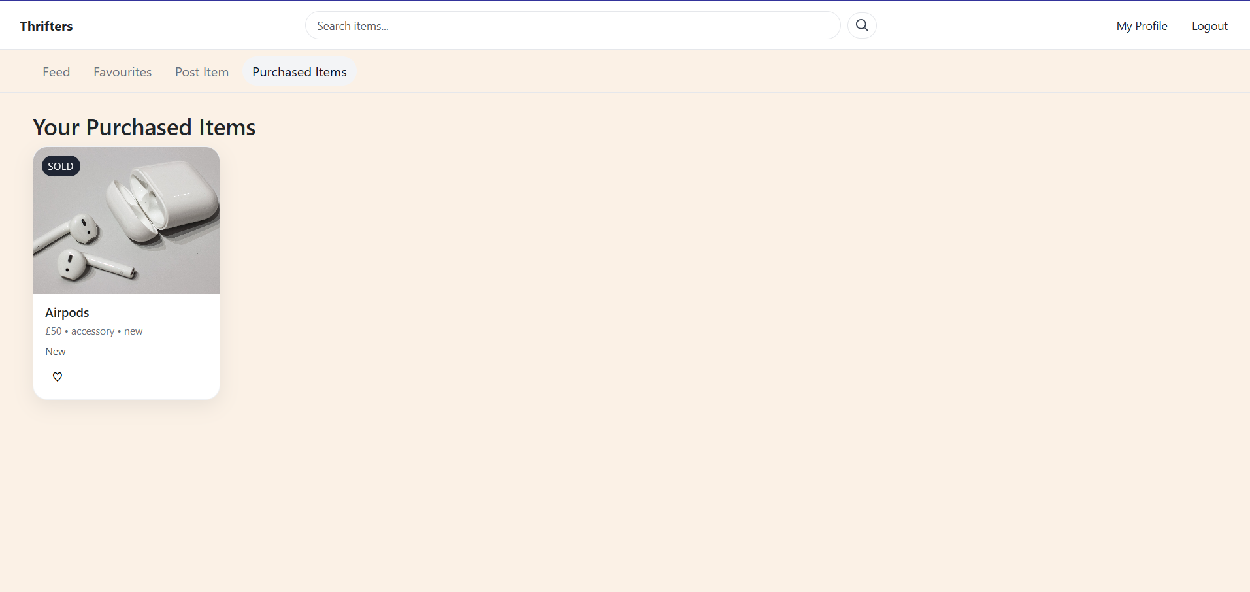
- Purchased page: items the user bought.

- Modals: “Post item” modal (AJAX upload + create); “Purchase” modal (address + card number; marks item SOLD); “Buyer Info” modal (seller-only view of buyer address & card last-4).
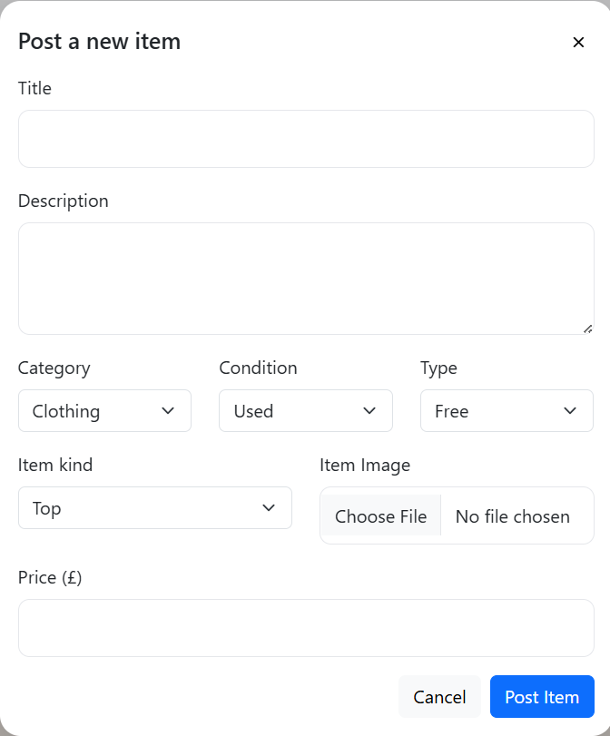

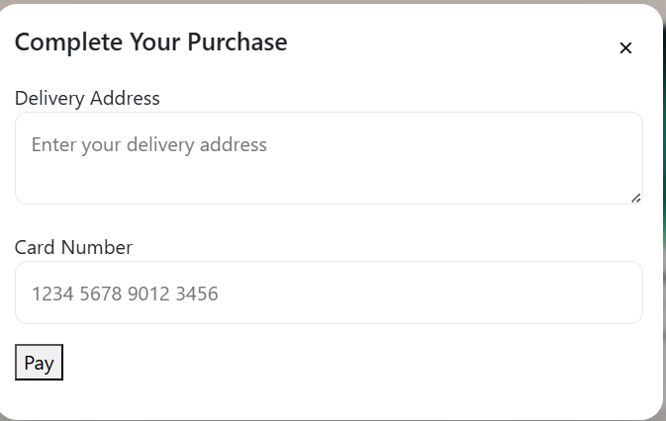

The UI avoids intrusive alert boxes and uses inline messages/status where appropriate.

3. System Architecture
- Front end: one index.html + style.css + app.js (Bootstrap for styling). Sections are shown/hidden via JS; no page reloads after initial load; fetch() for all AJAX calls; JSON responses are rendered into the DOM.
- Back end (web service): Node.js + Express; express-session to maintain login sessions; express.json() to accept JSON bodies; all paths start with /M01043814/.
- Database: MongoDB with Node’s mongodb driver; collections: users, items, follows, favorites. Images are stored on disk via multer, and their URLs are returned to the client.
- Security: passwords hashed (bcryptjs); sessions guard protected routes; purchaseDetails (buyer address, card last-4, timestamp) are redacted for everyone except the seller of the item and the buyer themselves.

4. Web Service Endpoints
Users
- POST /M01043814/users: register (JSON body → Mongo users, returns result).
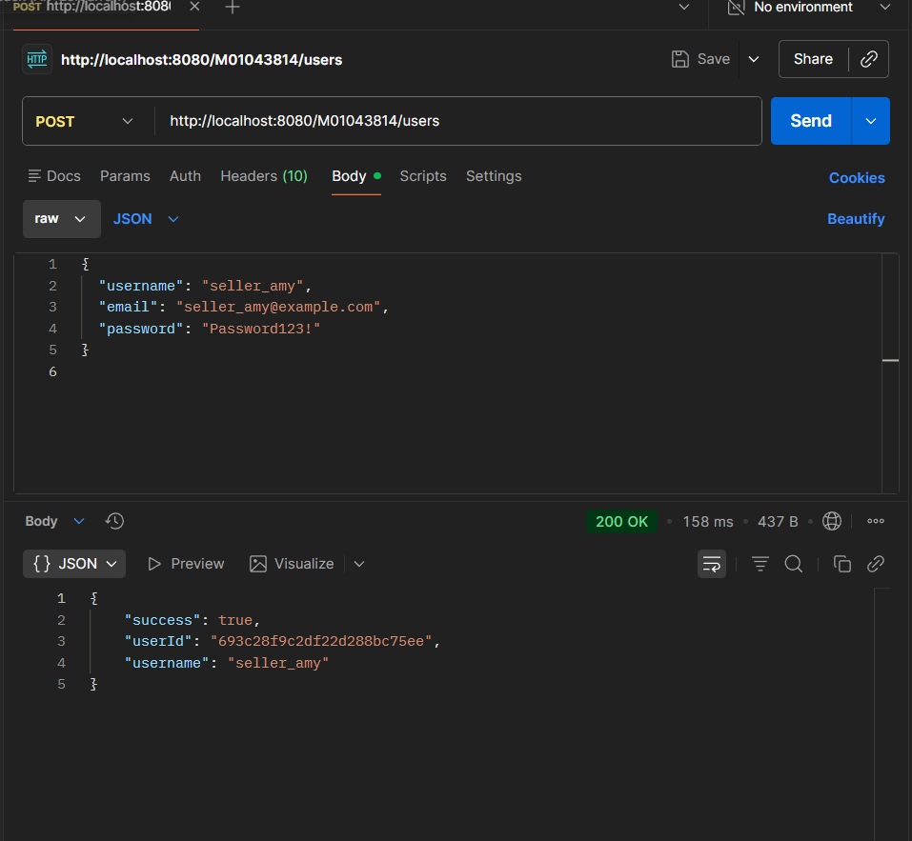

Login & Session
- GET /M01043814/login: login status.
- POST /M01043814/login: perform login (sets session).
- DELETE /M01043814/login: logout (destroys session).
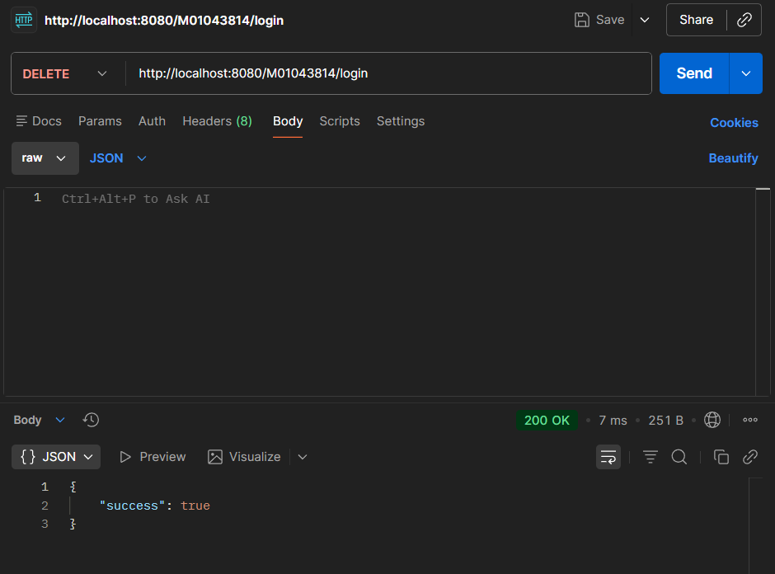
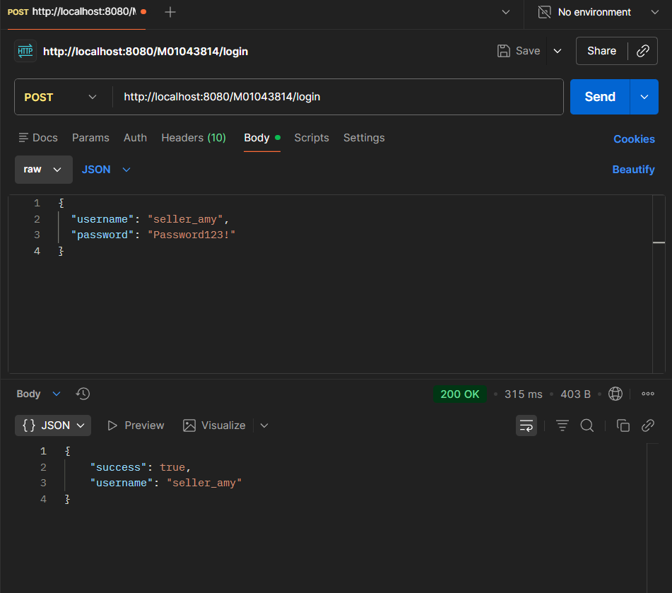
Social / Items
- POST /M01043814/contents: create an item post (title, desc, priceType/price, category, itemKind, image).
- GET /M01043814/contents?q=TEXT: search items (not restricted to follows; for discovery/search).
- POST /M01043814/follow: follow a user (body includes targetUserId).
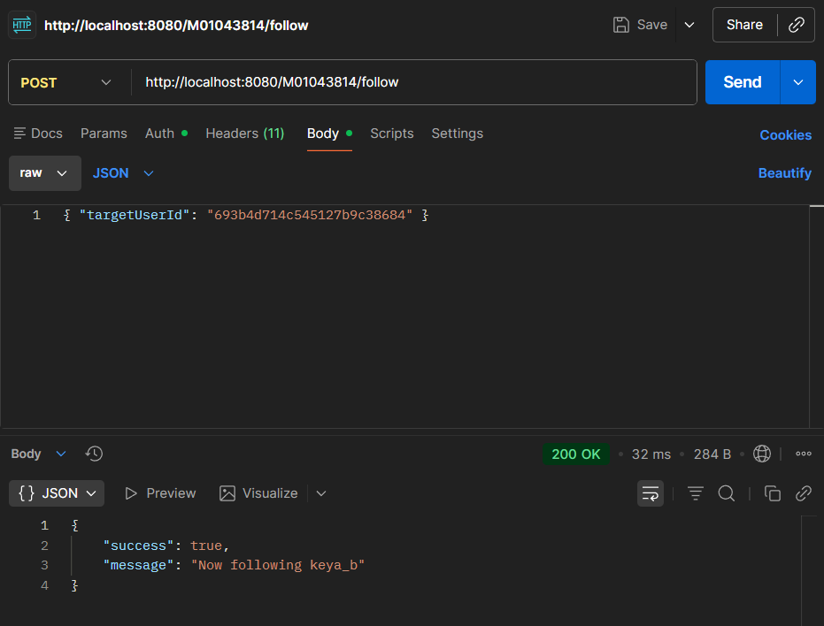
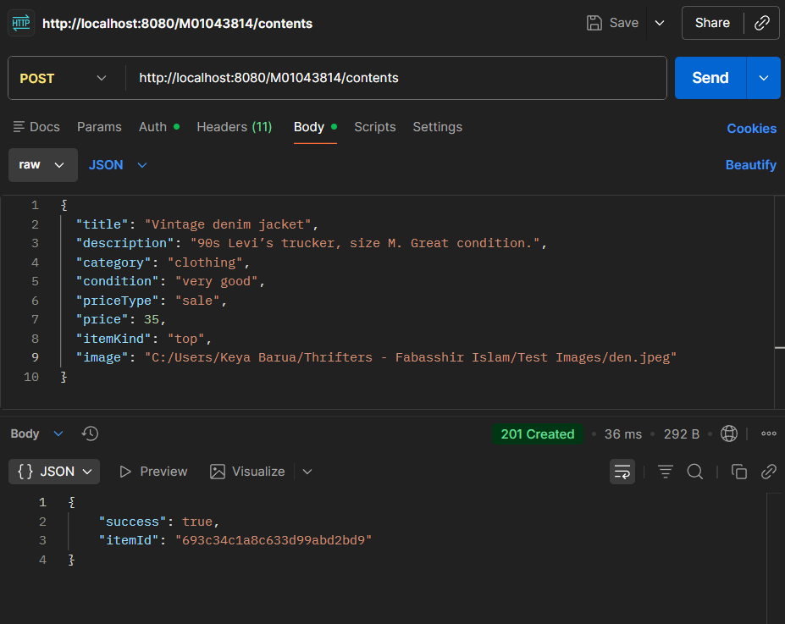
- GET /M01043814/feed: feed with only items from followed users (spec requirement).

Uploads
- POST /M01043814/upload/item: AJAX image upload to server filesystem; returns relative URL (used in item posts).
Third-party data (server-side only)
- GET /M01043814/weather?lat=..&lon=..: server fetches current-month climate data from a weather API, summarizes temperature/rainfall, and returns text and suggested keywords for the UI chips.
Advanced
- POST /M01043814/contents/:id/purchase: buyer submits address + card number; item is marked SOLD; seller sees buyer info; others see it redacted.
- GET /M01043814/purchased: items current user bought.
- POST /M01043814/favorites & DELETE /M01043814/favorites/:itemId & GET /M01043814/favorites : favourites feature.
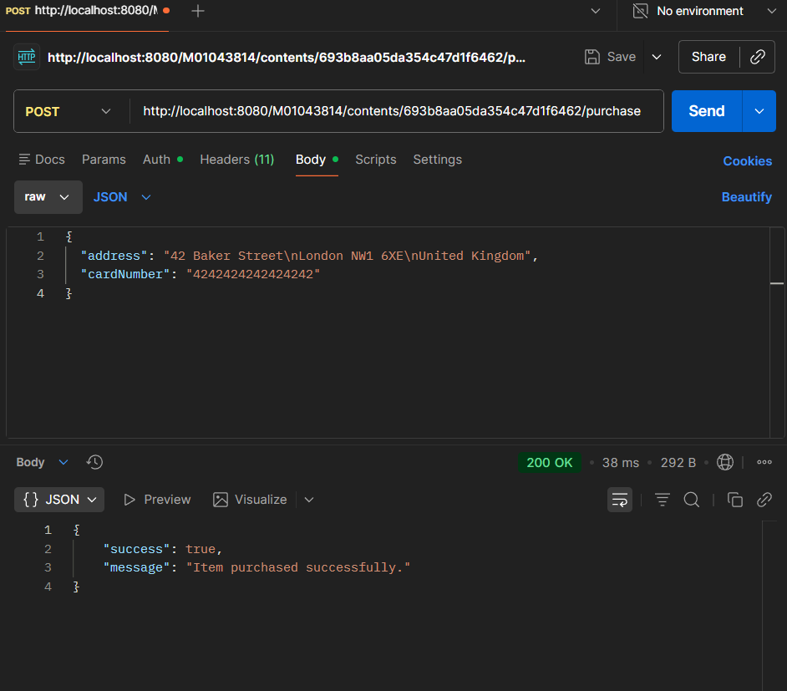
- GET /M01043814/sellers/suggestions[?q=...]: right-sidebar list and search of sellers to follow.

All endpoints return JSON; image upload is the only binary exception allowed.

5. Data Model
- users: { _id, username, email, passwordHash, avatar, location, createdAt }
- items: { _id, ownerId, title, description, category, condition, priceType, price, image, itemKind, status, createdAt, purchasedBy?, purchaseDetails?{ address, last4, purchasedAt } }
- follows: { _id, followerId, followedId, createdAt }
- favorites: { _id, userId, itemId, createdAt }
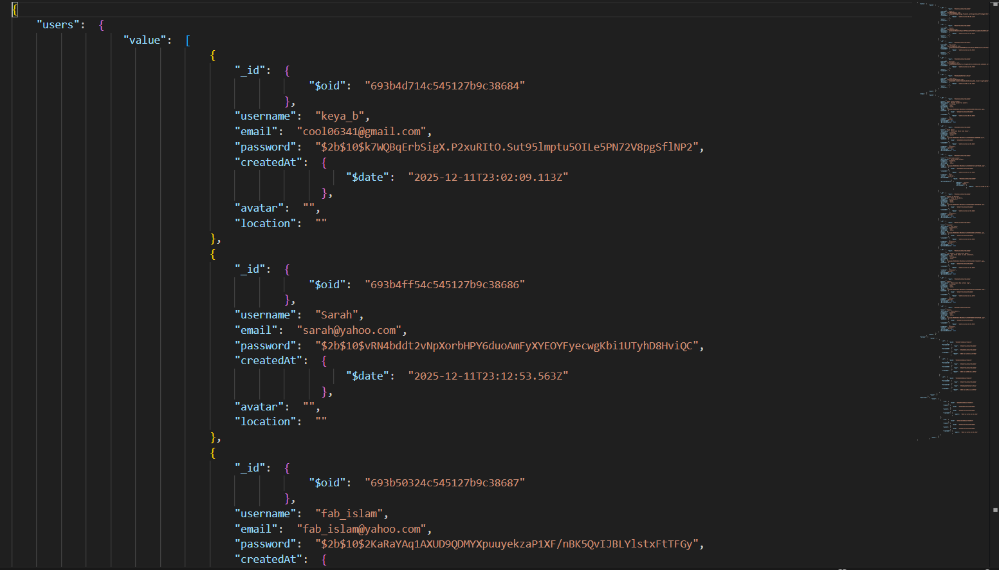
Passwords are hashed; purchaseDetails are returned only to the seller of that item or the buyer.

6. Third-Party Data Integration (Weather)
The brief requires that third-party data be fetched server-side and exposed via a path starting with the student ID; the front end must not call third-party services directly. The /M01043814/weather endpoint conforms to this rule and returns monthly climate summary and keyword suggestions. The front end displays a small animated scene (sun/cloud/rain/cold) and textual guidance; keyword chips trigger searches (but if the user follows no sellers, the chips politely ask the user to follow sellers first).

7. Testing Strategy
- Web service: Verified each endpoint with Postman (status, request/response JSON). I will include screenshots for: register, login (POST/GET/DELETE), users search, contents (POST/GET), follow (POST/DELETE), feed (GET), upload (POST), weather (GET), favourites (POST/GET/DELETE), purchase (POST) with success and error cases. The brief awards marks for Postman/Thunder screenshots for all functionality.
- Front end: Manual functional tests covering login/logout persistence via session; posting with and without image; following/unfollowing; feed visibility rules; favourites; purchase flow; redaction of buyer address for non-seller/non-buyer; weather chips gating when user has no follows.
- Database: Verified inserts/updates in MongoDB via Compass and quick JSON exports; ensured dump is BSON/JSON as required.

8. Issues Encountered & Solutions
- ES module vs. CommonJS warning and MIME issues: Resolved by consistent module usage and static serving under the student path.
- Mongo connection timeout (127.0.0.0): Corrected to 127.0.0.1 and ensured MongoDB service running.
- “Cannot POST /M01043814/contents” (404): Added the missing POST /…/contents route and restarted the correct server process.
- 401 Unauthorized when calling protected routes: Ensured login happens before AJAX calls; verified session cookie present.
- Follow endpoint 400: Validated targetUserId and prevented self-follow; improved client error display.
- Purchase modal not opening: Unified modal styling/JS (“app-modal”) for both Post and Purchase modals.
- Feed vertical list: Forced 3-column CSS grid on the feed container; removed nested wrapper that broke grid.
- Weather chips showing items when unfollowed: Added a follow-gate: if the user follows no one, chips trigger a friendly prompt rather than a search.

9. Accessibility Considerations
- Semantic layout (header/nav/main) and labelled controls on forms/modals.
- Sufficient contrast and focusable buttons/links.
- Reduced reliance on alerts; inline messages and aria-appropriate feedback preferred (aligns with marking notes on usability/alerts).

10. Security & Privacy
- Password hashing with bcrypt; sessions for authentication.
- Purchase details (address, card last-4, timestamp) are shown only to the seller of the item and to the buyer; redacted for others.
- Input validation and server-side checks on follow/purchase endpoints.
- Third-party API keys (where applicable) kept server-side; front end never calls third-party services directly (as per brief).

11. Performance Considerations
- Lightweight front end (vanilla JS + Bootstrap); no heavy frameworks.
- Images are sized for cards; animations are simple CSS (sun/cloud/rain) to avoid runtime jank.
- Basic indexes (e.g., on items.ownerId, follows.followerId, follows.followedId) improve feed queries.

12. Conclusion & Recommendations
Thrifters meets the Coursework 2 specification: a single-page front end, a Node/Express web service with student-ID-prefixed paths, AJAX/JSON, MongoDB via the official driver, image uploads, social networking features (register/login, user search, follow/unfollow, feed restricted to followed users), and third-party weather data fetched server-side and surfaced in the UI. The app adds useful extras like favourites, purchases/SOLD, seller-only buyer info, and seller search—qualifying for advanced functionality credit. For future work, I would add pagination and sorting to feeds, richer profile pages (avatars/location), and automated tests.

